PROXIMAL POLICY GRADIENT

:Policy gradient->
let us select the gaussian policy for continous action space
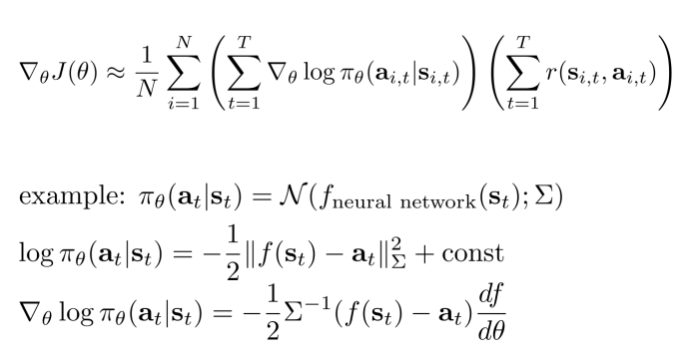

N trajectories each trajectory is having some t steps ; for each steps ie for each state/observation we would have mean and covariance matrix which is calculated by neural net.
So we would have a batch size of N each having t observatoions then for each t different statewe would have t different normal distributions from which we will calculate the probability of taking a action . This neural net is trained on parameter (theta)

